Draft
Planning Proposal to Reclassify Community Land to Operational Land at
19 Gibraltar Street Bungendore

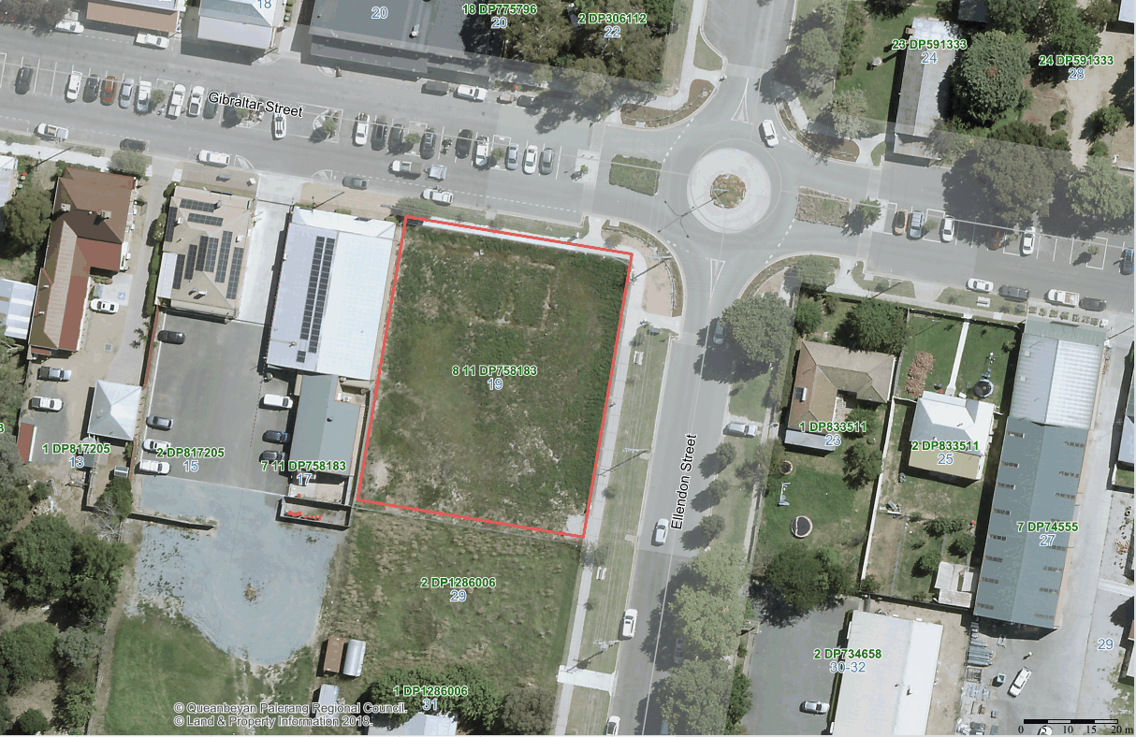

ECM Ref: 2479144

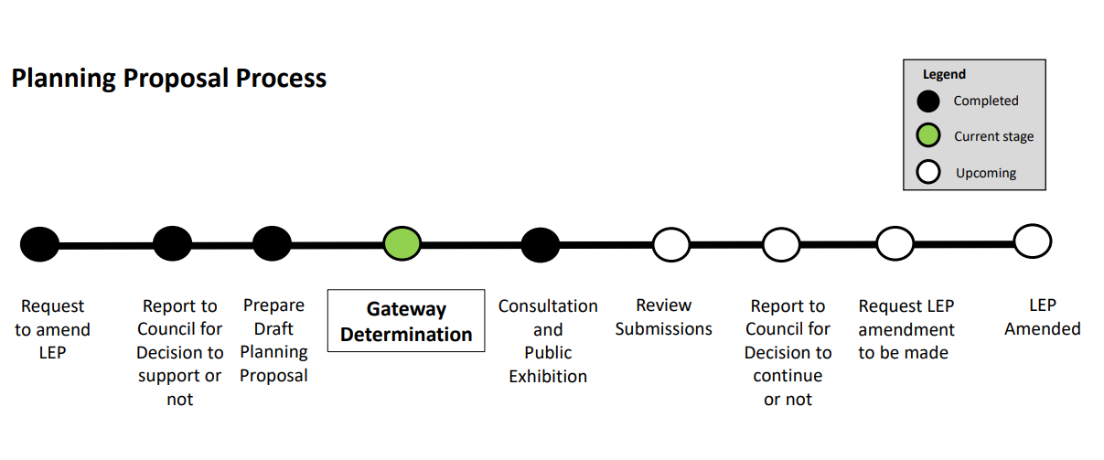

Document History
Version | Dated | Comments
1 | March 2024 | ECM ID 2479144

Offices: Council Headquarters - 257 Crawford St
Bungendore Office – 10 Majara St
Braidwood Office – 144 Wallace St

Contact: Phone 1300 735 025
E: council@qprc.nsw.gov.au
W: www.qprc.nsw.gov.au
Table of Contents
Introduction 4
Part 1 - Objectives or Intended Outcomes 6
Part 2 - Explanation of Provisions 6
Part 3 - Justification Strategic and Site-Specific Merit 6
Section A – Need for the Planning Proposal 6
Section B - Relationship to Strategic Planning Framework 7
Section C - Environmental, Social and Economic Impact 8
Section D - Infrastructure (Local, State and Commonwealth) 8
Section E - State and Commonwealth Interests 8
Part 4 - Maps 9
Part 5 - Community Consultation 9
Part 6 - Project Timeline 9
Appendix A - Information Checklist for Proposals to Classify or Reclassify Public Land through a Local Environmental Plan (LEP) 10
Appendix B – State Environmental Planning Policies 13
Appendix C - Section 9.1(2) - Local Planning Directions (Current as of 10 November 2023) 14

Introduction

The purpose of this planning proposal is to reclassify certain Council owned land from ‘community’ to ‘operational’ under the Local Government Act 1993 (LG Act). The reclassification is required to facilitate construction of a new Queanbeyan-Palerang Regional Council (QPRC) building in Bungendore, following the acquisition of the former QPRC office building by the NSW Department of Education.

The parcel of land proposed for reclassification is located at 19 Gibraltar Street (Lot 8, Section 11, DP 758183), at the corner of Gibraltar St and Ellendon St within the Bungendore township, as shown in Figure 1, 2 and 3.

The land covers an area of 2023 ㎡and is currently Zoned E1 Local Centre under the Queanbeyan-Palerang Regional Local Environment Plan 2022 (QPRLEP 2022).

The planning proposal does not seek changes to existing zoning, minimum lot size, or floor space ratio controls and has been prepared in accordance with Section 3.33 of the Environmental Planning and Assessment Act 1979 (EP&A Act).

Figure 1 - Land proposed to be reclassified - 19 Gibraltar Street Bungendore

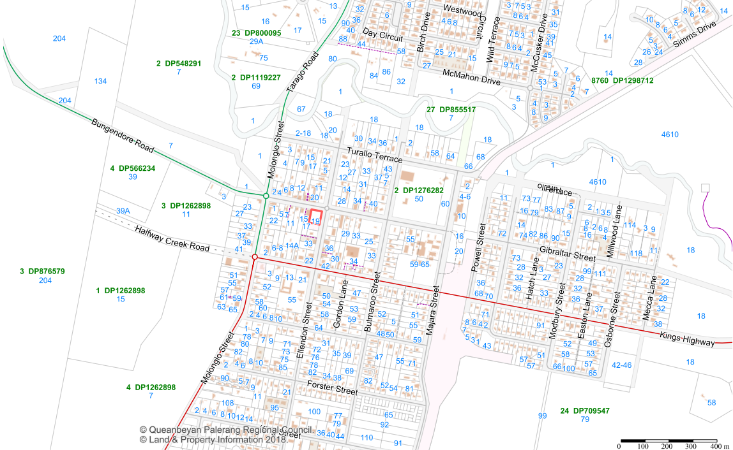

Figure 2 - Aerial view of land to be reclassified - 19 Gibraltar Street Bungendore

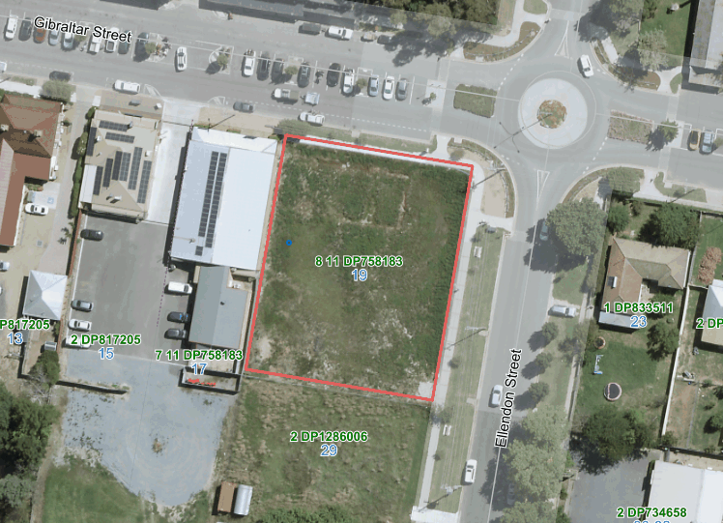

Figure 3 – Zoning of land to be reclassified

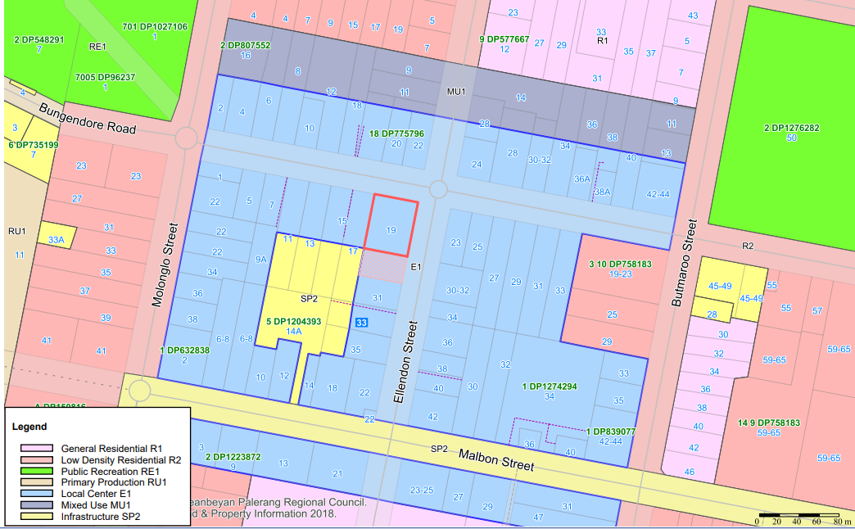

Part 1 - Objectives or Intended Outcomes

The objective of this planning proposal is to facilitate the construction of a new Queanbeyan-Palerang Regional Council (QPRC) building to carry out Council functions on the land.

The lot is currently vacant and Council is considering an option to consolidate the office, library, and community centre into a single facility at 19 Gibraltar Street Bungendore.

Part 2 - Explanation of Provisions

Queanbeyan-Palerang Regional Council purchased 19-21 Gibraltar Street Bungendore (Lot 8 Sec 11 DP 758183) on 5 August 2021 and the classification of the site defaulted to ‘community’ under the Local Government Act 1993 (LG Act).

This planning proposal seeks to reclassify the subject land from ‘community’ to ‘operational’ to allow for the construction of a new Council building. This will be done by amending the Queanbeyan-Palerang Regional Environmental Plan 2022 (QLEP 2022) to include the subject land in Part 1 of Schedule 4 (no interests changed) of the plan. The proposal does not seek to change any trusts, estates, interests, dedications, conditions, restrictions, or covenants on the land.

Consistent with the provisions of clause 5.2(2) of the QLEP 2022, this will have the effect of reclassifying the land as intended.

Part 3 - Justification Strategic and Site-Specific Merit

Section A – Need for the Planning Proposal

- Is the planning proposal a result of an endorsed local strategic planning statement (LSPS), strategic study or report?

No. However, the planning proposal is considered to be of local significance only and will require both public exhibition under the LG Act.

Council resolves at its Ordinary Meeting on 22 November 2023 that the subject land be reclassified in accordance with the LG Act.

- Is the planning proposal the best means of achieving the objectives or intended outcome, or is there a better way?

In accordance with Section 31. (2) (2A) of the LG Act, the Council may resolve to classify acquired land as ‘community’ or ‘operational’ either prior to or within three months after acquisition. Land that remains unclassified after this period is automatically deemed to be classified as ‘community’ under the LEP. Council in this instance did not resolve to classify the land in the required timeframe.

Therefore, this planning proposal to amend the LEP is the only mechanism that allows for reclassifying the subject land from ‘community’ to ‘operational’.

Section B - Relationship to Strategic Planning Framework

- Will the planning Proposal give effect to the objectives and actions of the applicable regional, or district plan or strategy (including any exhibited draft plans or strategies)

The planning proposal aligns with Objective 3 of the Draft Southeast and Tablelands Regional Plan 2041, which aims to "Support diverse, vibrant and socially active communities." The new council building to be constructed on the subject land will incorporate a community centre and library, facilitating a high-quality public domain that promotes social gathering and engagement.

The Department of Planning, Housing and Infrastructure (DPHI) has also previously published LEP Practice Note PN 16-001: Classification and reclassification of public land through a local environmental plan. This practice note provides guidance on additional matters to be addressed in planning proposals that seek to classify or reclassify public land.

Responses to the additional matters set out in the practice note are provided at Appendix A.

- Is the planning proposal consistent with the Council Local Strategic Planning Statement (LSPS) that has been endorsed by the Planning Secretary or Greater Sydney Commission (GSC), or another local strategy or strategic plan?

The Queanbeyan-Palerang Regional Council Local Strategic Planning Statement, ‘Towards 2040’ (LSPS) together with the Community Strategic Plan 2018-2028, set out the community’s long term vision and aspirations for Council’s planning activities.
Planning Priority 10 of the LSPS is relevant to the planning proposal:
We plan for and provide regional facilities which promote better social connection and access to the community.
- Is the planning proposal consistent with any other applicable State and Regional Studies or Strategies?

State or regional study or strategy | Comment
Future Transport Strategy 2056 | The proposal is consistent with the strategy
Cumberland Plain Conservation Plan | The proposal is consistent with the plan
Net Zero Plan | The proposal is consistent with the plan
Water Resources Plan | The proposal is consistent with the plan
State Infrastructure Strategy | The proposal is consistent with the strategy
A 20 year Economic Vision for Regional NSW | The proposal is consistent with the vision

- Is the planning proposal consistent with applicable State Environmental Planning Policies (SEPPS)?

The planning proposal has been assessed against State Environmental Planning Policies (SEPP’s) at Appendix B.

- Is the planning proposal consistent with applicable Minsters Directions (section 9.1(2) Directions)?

The relevant Ministerial Directions (Section 9.1) have been considered at Appendix C.

Section C - Environmental, Social and Economic Impact

- Is there any likelihood that critical habitat or threatened species, population or ecological communities, or their habitats, will be adversely affected because of the proposal?

No. The planning proposal does not apply to land that has been identified as containing critical habitat or threatened species, populations or ecological communities, or their habitats.

- Are there any other likely environmental effects of the planning proposal and how are they proposed to be managed?
Flood modelling completed as part of the Bungendore Floodplain Risk Management Study (WorleyParsons, 2014) indicates that part of the subject land is flood affected. As such, any proposed development of the land will need to comply with flood requirements of the QPRLEP 2022, Palerang Development Control Plan 2015 and the Department of Climate Change, Energy, the Environment and Water’s guidelines detailed in Section 9.1 (2) Local Planning Direction 4.1 Flooding.
The planning proposal is not considered to have any other likely environmental effects and any unexpected environmental effects can be resolved during the assessment of a development application.

- How has the planning proposal adequately addressed any social and economic issues?

The ‘community’ land is intended to be reclassified as ‘operational’ land for the future construction of a new Bungendore QPRC office. The office provides employment for the community in the surrounding township and social benefits such a library and meeting rooms for the community.

Appendix A provides further analysis of the requirements set out under Practice Note PN 16-001.

Section D - Infrastructure (Local, State and Commonwealth)

- Is there adequate public infrastructure for the planning proposal?

The subject land is centrally located within the Bungendore town area, within the middle of the employment zone, and is surrounded by commercial and retail establishments. Infrastructure mapping reveals comprehensive services, including water, sewer, gas, stormwater drainage, and electricity. Any additional services required for the development may be subject to conditions during the Development Assessment (DA) stage.

Section E - State and Commonwealth Interests

- What are the views of State and Commonwealth Public authorities and government agencies consulted to order to inform the Gateway determination?

Consultation with public authorities will be undertaken in accordance with the Gateway determination received for the planning proposal.

Part 4 - Maps

No mapping is required to support the planning proposal.

Part 5 - Community Consultation

The planning proposal is required to be exhibited for a minimum period of 28 days. At the conclusion of the public exhibition period, a public hearing will also be held as required under the Local Government Act 1993.

Part 6 - Project Timeline

Stage | Anticipated Timeline  (2023-2024)
Prepare Planning Proposal | November 2023
Report to Council | November 2023
Gateway Determination | March 2024
Agency Consultation | Subject to Gateway determination
Public Exhibition | April - May 2024
Public Hearing | June 2024
Report to Council including consideration of submissions | May 2024
Parliamentary Council Opinion | July 2024
Plan Finalised by Minister (or delegate) | August 2024

Appendix A - Information Checklist for Proposals to Classify or Reclassify Public Land through a Local Environmental Plan (LEP)

NSW Government’s Framework - LEP Practice Note

NSW Planning and Environment has published LEP Practice Note PN 16-001: Classification and reclassification of public land through a local Environmental plan.
This practice note provides guidance on matters to be addressed in planning proposals to classify or reclassify public land.

The table below addresses these matters and identifies where matters are addressed in the planning proposal.

No. | Requirement | Comment
1 | The current and proposed classification of the land. | The subject land is currently classified as community land and is proposed to be reclassified to operational land under the provisions of the Local Government Act 1993.
2 | Whether the land is a ‘public reserve’ (defined in the LG Act). | The site is not defined as a ‘public reserve’ under the provisions of the Local Government Act 1993.  The property came into Council’s ownership on 5 August 2021 following the Council’s purchase of the land from a private landowner.  Following Council’s acquisition of the subject land, it should have been classified as ‘operational’ land within three months, however, this was not completed at the time due to an oversight and the site was given ‘community’ land status by default.
3 | The strategic and site-specific merits of the reclassification and evidence to support this. | The planning proposal is to address the one-off reclassification of the land. The new proposed building will contain new Bungendore Council offices, a library, and a community centre.
4 | Whether the planning proposal is the result of a strategic study or report. | The planning proposal is not a result of a strategic study or report.
5 | Whether the planning proposal is consistent with council’s community plan or any other local strategic plan. | The planning proposal is not inconsistent with Council’s community plan or any other local strategic plan.
6 | A summary of council’s interests in the land including:  - How and when the land was first acquired (e.g. was it dedicated, donated, provided as part of a subdivision for public open space or other or other purposes, or a developer contribution)  - If council does not own the land, the landowner’s consent  - The nature of any trusts, dedications, etc. | The subject parcel of land was purchased from a private landowner by Council on 5 August 2021 (settlement date). The land is currently owned by Council.  There are no known trusts, dedications, or interests that exist on the land.
7 | Whether an interest in land is proposed to be discharged, and if so, an explanation of the reason why. | The interest in the land is not proposed to be discharged.
8 | The effect of the reclassification (including, the loss of public open space, the land ceases to be a public reserve or particular interests will be discharged). | The effect of the reclassification will be that the subject land will be operational, allowing Council to construct new Council offices in Bungendore.
9 | Evidence of public reserve status or relevant interests, or lack thereof applying to the land (e.g. electronic title searches, notice in Government Gazette, trust documents). | The subject land does not have Public Reserve status. The title and deposited plan are included in Appendix D of the planning proposal as evidence.
10 | Current use(s) of the land, and whether uses are authorised or unauthorised. | The current use of the land is a vacant fenced lot.
11 | Current or proposed lease or agreements applying to the land, together with their duration, terms, and controls. | There is no current or proposed lease on the land. It is Council owned community land.
12 | Current or proposed business dealings (e.g. agreements for the sale or lease of the land, the basic details of any such agreements and if relevant, when council intends to release its assets, either immediately after rezoning/reclassification or at a later time). | After the reclassification to operational land, Council will be able to apply for a development application for the construction of new Council offices.
13 | Any rezoning associated with the reclassification (if yes, need to demonstrate consistency with an endorsed Plan of Management or strategy). | The planning proposal does not propose to rezone the subject land.
14 | How council may or will benefit financially, and how these funds will be used. | Council will not benefit financially as the maintenance and insurance of the subject land will rest with Council.
15 | How council will ensure funds remain available to fund proposed open space sites or improvements referred to in justifying the reclassification, if relevant to the proposal. | This planning proposal does not commit funds to any proposed open space or specific improvements.
16 | A Land Reclassification (part lots) Map, in accordance with the standard technical requirements for special datasets and maps, if land to be reclassified does not apply to the whole lot. | Not relevant. The land re-classification applies to the whole lot.
17 | Preliminary comments by the relevant government agency, including an agency that dedicated the land to council, if applicable. | The land is owned by Council. No formal consultation with State or Commonwealth public authorities has been undertaken at this stage. However, consultation will be undertaken with State and Commonwealth agencies in accordance with the Gateway determination, if required.
18 | The concurrence of the landowner must be obtained, where the land is not owned by the Planning Proposal Authority (PPA). | The land is owned by the Council (Planning Proposal Authority – PPA).
19 | Does the planning proposal deliver a public benefit? | The planning proposal seeks to provide land that a new Council office that will be constructed in Bungendore. The proposal will include a new Council library and community centre.
20 | Have the implications for the open space in the LGA in relation to current and future open space needs been considered and will there be a net gain to open space? | The implications for open space in Bungendore have been considered. The site is not defined as a ‘public reserve’ under the provisions of the Local Government Act 1993. The proposal does not affect the current and future open space.

Appendix B – State Environmental Planning Policies

The following relevant Environmental Planning Instruments (EPI) have been considered in the preparation of this planning proposal:

SEPP | Relevant | Comments
State Environmental Planning Policy (Biodiversity and Conservation) 2021. | No | This SEPP applies to Queanbeyan-Palerang Regional Council (QPRC).  This planning proposal will not affect the operation of the SEPP.
State Environmental Planning Policy (Exempt and Complying Development Codes) 2008. | No | This SEPP applies to QPRC.  This planning proposal will not affect the operation of the SEPP.
State Environmental Planning Policy (Housing) 2021. | No | This SEPP applies to QPRC.  This planning proposal will not affect the operation of the SEPP.
State Environmental Planning Policy (Industry and Employment) 2021. | No | This SEPP applies to QPRC.  This planning proposal will not affect the operation of the SEPP.
State Environmental Planning Policy No 65—Design Quality of Residential Apartment Development (2002 EPI 530). | No | This SEPP applies to QPRC.  This planning proposal will not affect the operation of the SEPP.
State Environmental Planning Policy (Planning Systems) 2021. | No | This SEPP applies to QPRC.  This planning proposal will not affect the operation of the SEPP.
State Environmental Planning Policy (Precincts—Central River City) 2021. | No | This SEPP does not apply to QPRC.
State Environmental Planning Policy (Precincts—Eastern Harbour City) 2021. | No | This SEPP does not apply to QPRC.
State Environmental Planning Policy (Precincts—Regional) 2021. | No | This SEPP does not apply to QPRC.
State Environmental Planning Policy (Precincts—Western Parkland City) 2021. | No | This SEPP does not apply to QPRC.
State Environmental Planning Policy (Primary Production) 2021. | No | This SEPP applies to QPRC.  This planning proposal will not affect the operation of the SEPP.
State Environmental Planning Policy (Resilience and Hazards) 2021. | No | This SEPP applies to QPRC.  This planning proposal will not affect the operation of the SEPP.
State Environmental Planning Policy (Resources and Energy) 2021. | No | This SEPP applies to QPRC.  This planning proposal will not affect the operation of the SEPP.
State Environmental Planning Policy (Sustainable Buildings) 2022. | No | This SEPP applies to QPRC.  This planning proposal will not affect the operation of the SEPP.
State Environmental Planning Policy (Transport and Infrastructure) 2021. | No | This SEPP applies to QPRC.  This planning proposal will not affect the operation of the SEPP.

Appendix C - Section 9.1(2) - Local Planning Directions (Current as of 10 November 2023)

The following relevant Local Planning Directions under Section have been considered in the preparation of this planning proposal:
Consideration of s9.1 Directions | Comments
Focus area 1: Planning Systems
1.1 Implementation of Regional Plans | Applicable. The planning proposal is consistent with the provisions of this direction
1.2 Development of Aboriginal Land Council land | Not applicable. The subject land is not shown on the Land Application Map of chapter 3 of the SEPP (Planning Systems)
1.3 Approval and Referral Requirements | Applicable. The planning proposal is substantially consistent with the provisions of this direction
1.4 Site Specific Provisions | Applicable. The planning proposal is consistent with the provisions of this direction
1.4A Exclusion of development standards from variation | Applicable. The planning proposal is consistent with the provisions of this direction
Focus area 1: Planning Systems – place based
1.5 Parramatta Road Corridor Urban Transformation Strategy | Not relevant to the proposal
1.6 Implementation of North West Priority Growth Area Land Use and Infrastructure Plan | Not relevant to the proposal
1.7 Implementation of Greater Parramatta Priority Growth Area Interim Land Use Infrastructure Implementation Plan | Not relevant to the proposal
1.8 Implementation of Wilton Priority Growth Area Interim Land Use Infrastructure Implementation Plan | Not relevant to the proposal
1.9 Implementation of Glenfield to Macarthur Urban Renewal Corridor | Not relevant to the proposal
1.10 Implementation of Western Sydney Aerotropolis Plan | Not relevant to the proposal
1.11 Implementation of Bayside West Precincts 2036 Plan | Not relevant to the proposal
1.12 Implementation of Planning Principles for the Cooks Cove Precinct | Not relevant to the proposal
1.13 Implementation of St Leonards and Crows Nest 20236 Plan | Not relevant to the proposal
1.14 Implementation of Greater Macarthur 2040 | Not relevant to the proposal
1.15 Implementation of Pyrmont Peninsula Place Strategy | Not relevant to the proposal
1.16 North West Rail Link Corridor Strategy | Not relevant to the proposal
1.17 Implementation of the Bays West Place Strategy | Not relevant to the proposal
1.18 Implementation of the Macquarie Park Innovation Precinct | Not relevant to the proposal
1.19 Implementation of the Westmead Place Strategy | Not relevant to the proposal
1.20 Implementation of the Camellia-Rosehill Place Strategy | Not relevant to the proposal
1.21 Implementation of the South West Growth Area Structure Plan | Not relevant to the proposal
1.22 Implementation of the Cherrybrook Station Place Strategy | Not relevant to the proposal
Focus area 2: Design and Place
Focus area 3: Biodiversity and Conservation
3.1 Conservation Zones | Not relevant to the proposal
3.2 Heritage Conservation | Not relevant to the proposal
3.3 Sydney Drinking Water Catchments | Not relevant to the proposal
3.4 Application of C2 and C3 zones and Environmental Overlays in Far North Coast LEPs | Not relevant to the proposal
3.5 Recreation Vehicle Areas | Not relevant to the proposal
3.6 Strategic Conservation Planning | Not relevant to the proposal
3.7 Public Bushland | Not relevant to the proposal
3.8 Willandra Lakes Region | Not relevant to the proposal
3.9 Sydney Harbour foreshores and Waterways Area | Not relevant to the proposal
3.10 Water Catchment Protection | Not relevant to the proposal
Focus area 4: Resilience and Hazards
4.1 Flooding | Applicable. The subject land is identified as flood prone area in Bungendore Floodplain Risk Management Plan adopted by the QPRC, which demonstrates the proposal is consistent with the provisions of this direction.  Further investigation and flood impact and risk assessment report may be required at the development application (DA) stage.
4.2 Coastal Management | Not relevant to the proposal
4.3 Planning for Bushfire Protection | Not relevant to the proposal
4.4 Remediation of Contaminated Land | Not relevant to the proposal
4.5 Acid Sulfate Soils | Not relevant to the proposal
4.6 Mine Subsidence and Unstable Land | Not relevant to the proposal
Focus area 5: Transport and Infrastructure
5.1 Integrating Land Use and Transport | Applicable. The planning proposal is consistent with the provisions of this direction
5.2 Reserving Land for Public Purposes | No applicable.  The proposal does not reduce land available for public reserves and facilities. The land was purchased from a private landowner and is not intended to be used as public land.
5.3 Development near regulated airports and defence airfields | Not relevant to the proposal
5.4 Shooting ranges | Not relevant to the proposal
Focus area 6: Housing
6.1 Residential Zones | Not relevant to the proposal
6.2 Caravan Parks and Manufactured homes estates | Not relevant to the proposal
Focus area 7: Industry and Employment
7.1 Employment Zones | Not relevant to the proposal
7.2 Reduction in non-hosted short-term rental accommodation period | Not relevant to the proposal
7.3 Commercial and retail development along the Pacific Highway North Coast | Not relevant to the proposal
Focus area 8: Resources and Energy
8.1 Mining, Petroleum Production and Extractive Industries | Not relevant to the proposal
Focus Area 9: Primary Production
9.1 Rural Zones | Not relevant to the proposal
9.2 Rural Lands | Not relevant to the proposal
9.3 Oyster Aquaculture | Not relevant to the proposal
9.4 Farmland of State and Regional Significance on the NSW Far Coast | Not relevant to the proposal

